**Pizza Sales SQL queries**

1. **KPI’s**
2. Total Revenue:

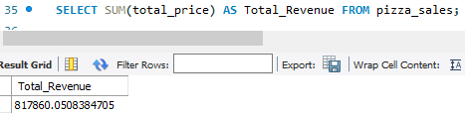

1. Average Order Value

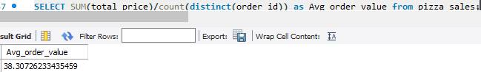

1. Total pizza sold

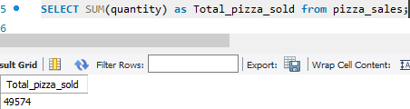

1. Total orders

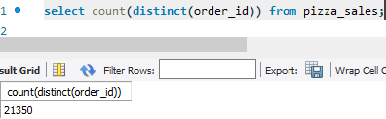

1. Average pizza per order

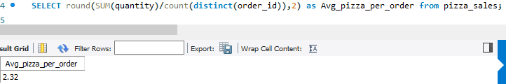

1. Daily trend for total orders(Bar Chart)

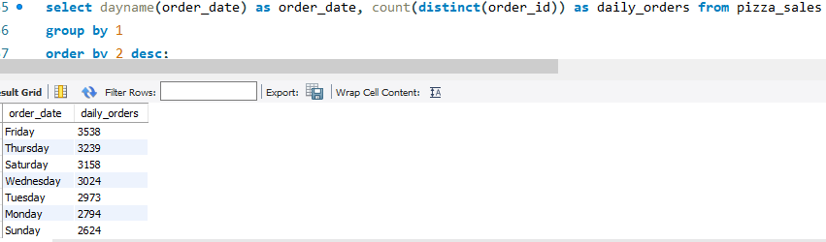

1. Monthly trend for total orders (line Chart)

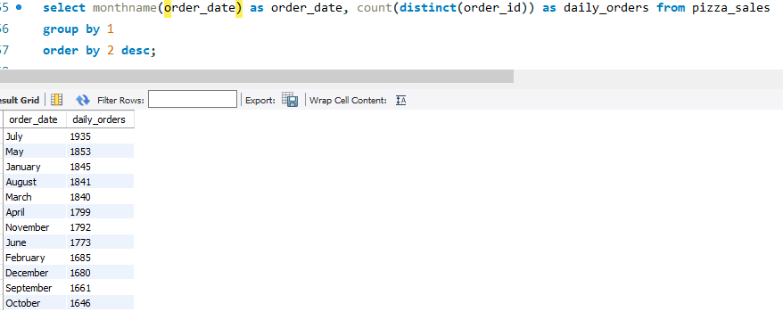

1. Percentage of sales by pizza category

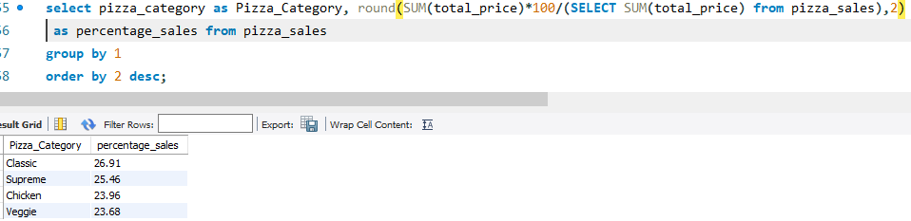

1. Percentage of sales by pizza category

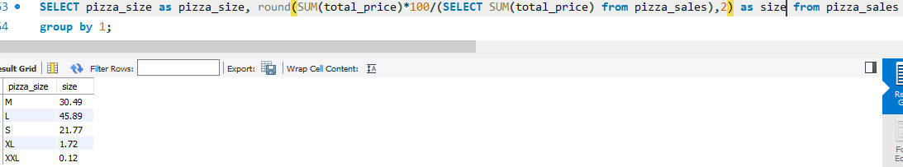

1. Top 5 best sellers by revenue, total quantity and total orders

Revenue

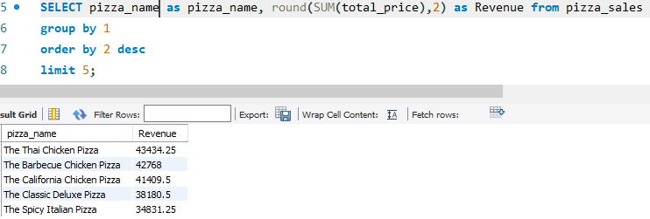

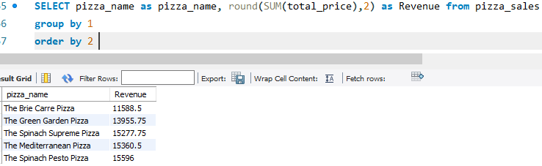

Quantity

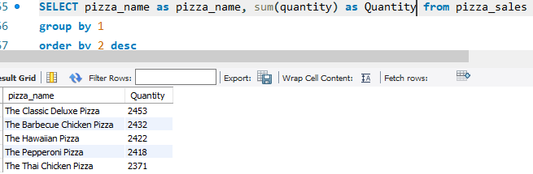

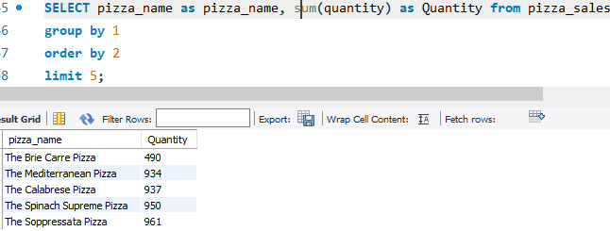

Total Orders:

